

SEM2 CSC 1706

PROBABILITY AND STATISTICS

Section 01 **Title :Impact of part time job on the CGPA.**

Submitted To:Dr. Raini Hassan

Group Member’s Name Matric no:

Md.Sariful Islam 1626667

Abu Sayed Mohammed Saad 1634677

Nasik Sami 1638153

Mahran Mujib 1632625

MD.Afique Amin Zian 1631005

**CONTENT**

|  |  |
| --- | --- |
| **SECTION** | **PAGE** |
| **ABSTRACT** | **01** |
| **INTRODUCTION** | **02** |
| **DATASET** | **03-06** |
| **H-Test (Formula for the Kruskal-Wallis Test)** | **07** |
| **Method – Preliminary Analysis** | **08-13** |
| **Analysis on category** | **14-17** |
| **R-Coding** | **18-23** |
| **Method – Full Scale Analysis** | **24** |
| **General Discussion** | **25** |
| **Conclusion and Recommendation** | **26** |
| **References & Appendix** | **27** |

**2. Abstract**

When we were asked to choose a topic for our probability assignment, we thought amongst ourselves; “What is the most controversial topic in Malaysia?” We decided to address the most hotly debated topic of all time: **Impact of part time job on the CGPA.**

Sometimes students do part time job for their extra income. But for the part time job, they waste a lot of their valuable time when they were suppose to study.

Based on previous researches, the results are divided in terms of agreeing whether part time job `have been giving positive or negative impacts on student performances. A study suggests a student’s overall engagement increases after working.

Therefore, we can logically assume that students with lower working time should have had better CGPA than those with higher hours. We distributed a survey and collected data from students of different name,years, kulliyyah, and levels of study. We then asked the respondents to key in their current CGPA.

In conclusion, we hypothesize students **with higher working hours have lower CGPA** due to the amount of distraction that are presented to the said students.

**3. Introduction**

The target for our survey audience are undergraduate students of International Islamic University Malaysia (IIUM). The survey was written up online on Google Forms and distributed through many WhatsApp messaging groups and various social media sites. We have managed to obtain 60 responses by random sampling.

In this survey, we have given three main choices for hours per day of part time job:

1. Less than 1 (one) hour
2. Between 1 (one) to 4 (four) hours
3. More than 4 (four) hours

We also asked the respondents of their thoughts on the effect of part time job on their academic life, and their current CGPA. Since most students are hesitant to share their CGPA, we have divided the CGPA into three categories.

The CGPA’s are classified into categories of:

1. 2.1 – 2.5
2. 2.6 – 3.0
3. 3.1 – 3.5
4. 3.6 – 4.0

We used a bar-chart for each category which is Less than 1 hour (X1), Between 1 to 4 hours (X2), and More than 4 hours (X3). We are assuming students who are working more than 4 hours has lower CGPA compared to a student who is working less than 1 hour.

DATA SET

Hours of part time job:

X1 = Less than 1 hour

X2 = between 1 and 4 hours

X3 = more than 4 hours

|  |  |  |
| --- | --- | --- |
| CGPA | Hours Of Work | Rank |
| 2.10 | X1 | 1 |
| 2.24 | X1 | 2 |
| 2.29 | X3 | 3 |
| 2.32 | X1 | 4 |
| 2.40 | X3 | 5 |
| 2.46 | X3 | 6 |
| 2.61 | X2 | 7.5 |
| 2.61 | X1 | 7.5 |
| 2.78 | X2 | 9 |
| 2.85 | X3 | 10 |
| 2.97 | X3 | 11 |
| 3.11 | X3 | 13 |
| 3.11 | X2 | 13 |
| 3.11 | X2 | 13 |
| CGPA | Hours Of Work | Rank |
| 3.30 | X3 | 15 |
| 3.32 | X2 | 16.5 |
| 3.32 | X1 | 16.5 |
| 3.35 | X3 | 18.5 |
| 3.35 | X1 | 18.5 |
| 3.37 | X2 | 20 |
| 3.39 | X2 | 21 |
| 3.40 | X1 | 23.5 |
| 3.40 | X2 | 23.5 |
| 3.40 | X2 | 23.5 |
| 3.40 | X1 | 23.5 |
| 3.42 | X2 | 26 |
| 3.43 | X3 | 27 |
| 3.45 | X2 | 28.5 |
| 3.45 | X2 | 28.5 |
| 3.47 | X2 | 30 |
| 3.49 | X2 | 31 |
| 3.50 | X3 | 33 |
| 3.50 | X1 | 33 |
| CGPA | Hours Of Work | Rank |
| 3.50 | X1 | 33 |
| 3.53 | X1 | 35 |
| 3.55 | X2 | 36 |
| 3.57 | X1 | 37.5 |
| 3.57 | X3 | 37.5 |
| 3.58 | X2 | 39.5 |
| 3.58 | X1 | 39.5 |
| 3.61 | X2 | 41 |
| 3.62 | X3 | 42 |

|  |  |  |
| --- | --- | --- |
| 3.65 | X2 | 43.5 |
| 3.65 | X1 | 43.5 |
| 3.66 | X2 | 45 |
| 3.69 | X1 | 46 |
| 3.70 | X1 | 47.5 |
| 3.70 | X2 | 47.5 |
| 3.74 | X2 | 49 |
| 3.79 | X1 | 51.5 |
| 3.79 | X2 | 51.5 |
| CGPA | Hours Of Work | Rank |
| 3.79 | X2 | 51.5 |
| 3.79 | X1 | 51.5 |
| 3.85 | X1 | 54 |
| 3.87 | X2 | 55 |
| 3.89 | X1 | 56 |
| 3.93 | X1 | 57 |
| 3.97 | X2 | 58 |
| 3.99 | X2 | 59 |
| 4.00 | X1 | 60 |

4. H-Test (Formula for the Kruskal-Wallis Test)

H0 = More hours of part time job have no effect on CGPA.

H1 = More hours of part time job have effect on CGPA. (Claim)

Critical Value:

Using Chi-Square Table G; d.f = 3-1=2; α=0.05;

C.V is 5.991.

Test Value:

R1=1+2+4+7.5+16.5+18.5+23.5+23.5+33+33+35+37.5+39.5+43.5+46+47.5+51.5+51.5+54+56+57+60 = 741.5;

R2=7.5+9+13+13+16.5+20+21+23.5+23.5+26+28.5+28.5+30+31+36+39.5+41+43.5+45+47.5+49+51.5+51.5+55+58+59 = 867.5

R3=3+5+6+10+11+13+15+18.5+27+33+37.5+42 = 221

H = [12/{60*(60+1)}] * [{(741.5*741.5)/22}+{(867.5*867.5)/26}+{(221*221)/12}] –{3*(60+1)}

= 7.186

7.186> 5.991

So, test value is greater than critical value. Decision is to reject null hypothesis. There is enough evidence to support the claim that more hours of job has effect on CGPA.

**5. Method – Preliminary Analysis**

|  |  |  |  |  |
| --- | --- | --- | --- | --- |
| CGPA  Class | Hours  In part time job | Class  Boundary | Frequency | Cumulative  Frequency |
| 2.1-2.5 | **X1**  **X2**  **X3** | 2.05-2.55 | **3**  **0**  **3** | 6 |
| 2.6-3.0 | **X1**  **X2**    **X3** | 2.55-3.05 | **1**  **2**  **2** | 11 |
| 3.1-3.5 | **X1**  **X2**  **X3** | 3.05-3.55 | **7**  **13**  **5** | 36 |
| 3.6-4.0 | **X1**  **X2**  **X3** | 3.55-4.05 | **11**  **11**  **2** | 60 |

Table 5.1: Relationships between Hours of part time job and CGPA

Less than one hour

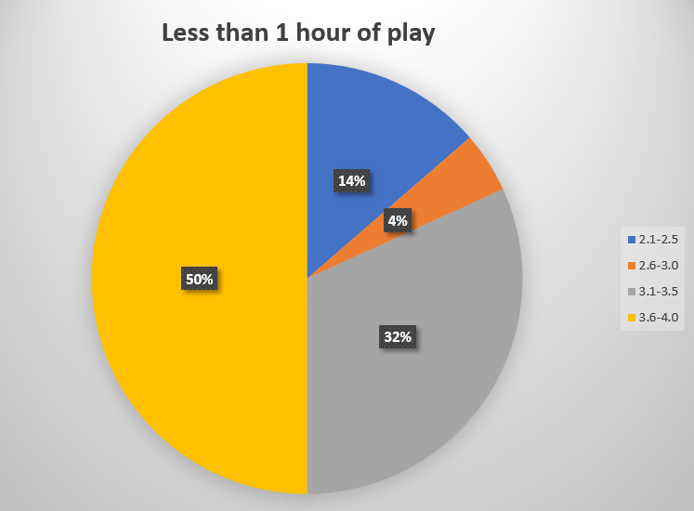

Figure 1: Pie chart off frequency of student’s CGPA

One to Four Hours of work

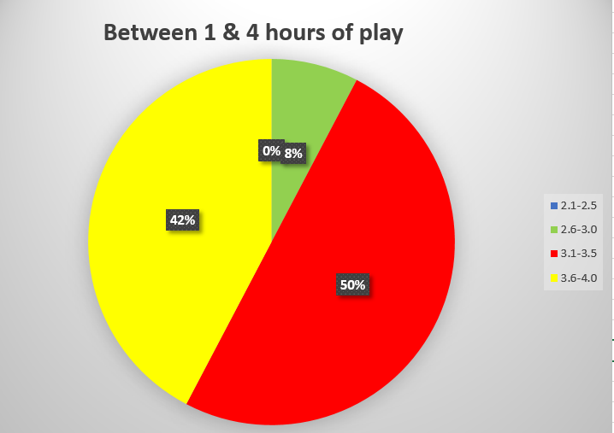

Figure 2: Pie chart off frequency of student’s CGPA

More than four hours

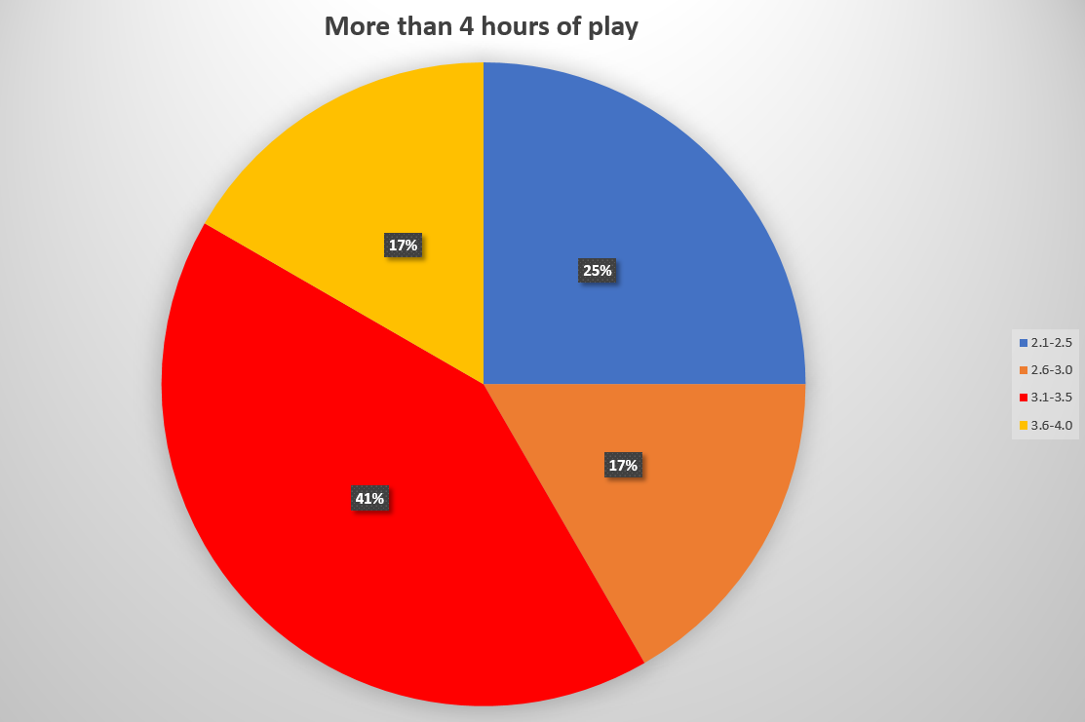

Figure 3: Pie chart off frequency of student’s CGPA

**5.1 Analysis on category: Who spend less than one hour**

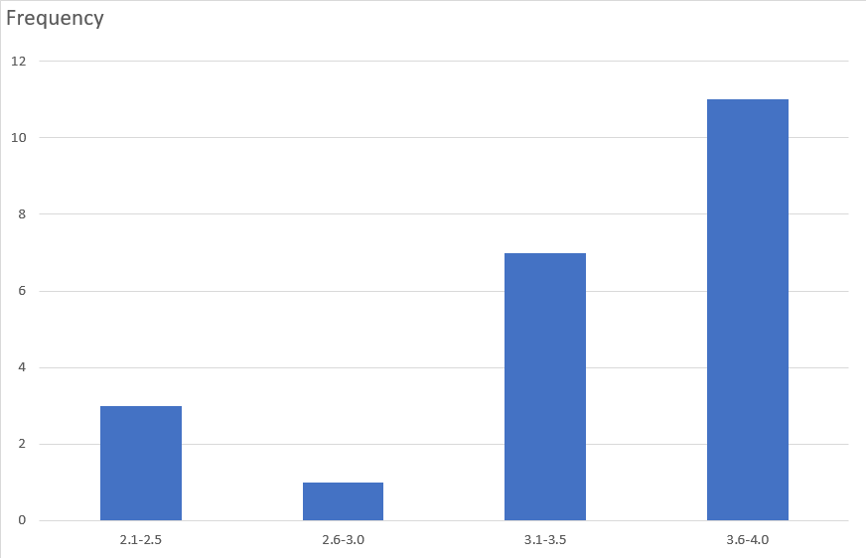

CGPA Class

*Figure 4*

**Mean** = {(3*2.3) + (1*2.8)+(7*3.3)+(11*3.8)}/22

= 3.39

**Modal Class** = 3.6 - 4.0

**Mode** = 3.8

**Midrange** = 3.05

**Variance** = {(22*258.78) - (74.6^2)}/ (22*21)

= 0.277

**Standard Deviation** = root over 0.277 = 0.526;

**Chebyshev’s Theorem**

Mean = 3.39

Standard Deviation = 0.526

For **75%** of data values fall between 2.338 and 4.442 as shown below:

3.39+ (2*0.526) = 4.442

3.39-(2*0.526) = 2.338

For **88.89%** of data values fall between 1.812 and 4.968 as shown below:

3.39+ (3*0.526) = 4.968

3.39-(3*0.526) = 1.812

For **93.75%** of data values fall between 1.286 and 5.494 as shown below:

3.39+(4*0.526) = 5.494

3.39-(4*0.526) = 1.286

Hence the mean falls within 4 standard deviation

**5.2 Analysis on category: Who spend between 1 & 4 hours**

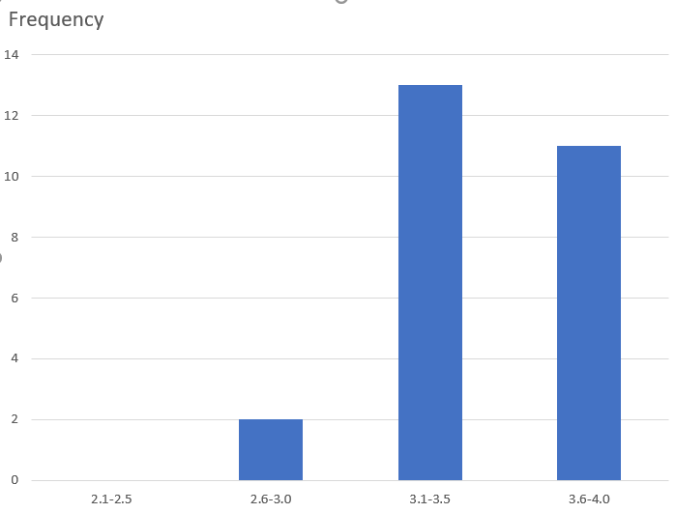

CGPA Class

*Figure 5*

**Mean** = {(0*2.3) + (2*2.8)+(13*3.3)+(11*3.8)}/26

= 3.47

**Modal Class** = 3.1 - 3.5

**Mode** = 3.3

**Midrange** = 3.05

**Variance** = {(26*316.09) - (90.3^2)}/ (26*25)

= 0.0988

**Standard Deviation** = root over 0.0988 = 0.314;

**Chebyshev’s Theorem**

Mean = 3.47

Standard Deviation = 0.314

For **75%** of data values fall between 2.842 and 4.098 as shown below:

3.47+(2*0.314) = 4.098

3.47-(2*0.314) = 2.842

For **88.89%** of data values fall between 2.528 and 4.412 as shown below:

3.47+(3*0.314) = 4.412

3.47-(3*0.314) = 2.528

For **93.75%** of data values fall between 2.214 and 4.726 as shown below:

3.47+(4*0.314) = 4.726

3.47-(4*0.314) = 2.214

Hence the mean falls within 4 standard deviation

**5.3 Analysis on category: Who spend more than four hours**

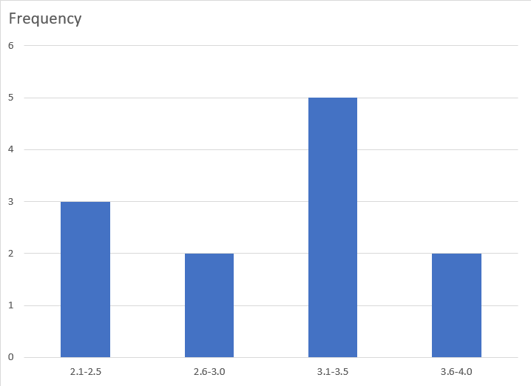

CGPA Class

*Figure 6*

**Mean** = {(3*2.3)+(2*2.8)+(5*3.3)+(2*3.8)}/12

= 3.05

**Modal Class** = 3.1 - 3.5

**Mode** = 3.3

**Midrange** = 3.05

**Variance** = {(12*114.88) - (36.6^2)}/ (12*11)

= 0.295

**Standard Deviation** = root over 0.295 = 0.543;

**Chebyshev’s Theorem**

Mean = 3.05

Standard Deviation = 0.543

For **75%** of data values fall between 1.964 and 4.136 as shown below:

3.05+(2*0.543) = 4.136

3.05-(2*0.543) = 1.964

For **88.89%** of data values fall between 1.421 and 4.679 as shown below:

3.05+(3*0.543) = 4.679

3.05-(3*0.543) = 1.421

For **93.75%** of data values fall between 0.878 and 5.222 as shown below:

3.05+(4*0.543) = 5.222

3.05-(4*0.543) = 0.878

Hence the mean falls within 4 standard deviation

**6. R-Coding**

**6.1** Histogram (total data)

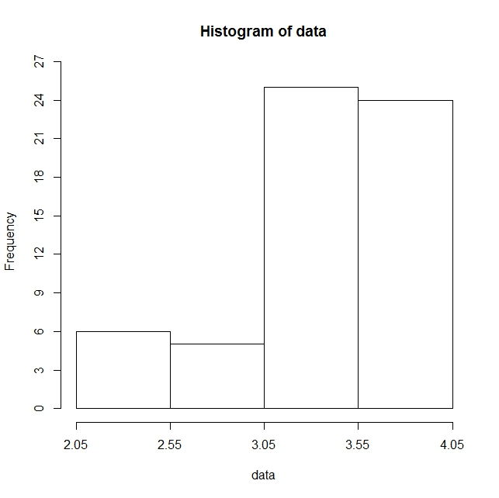

**Coding:**

**For Histogram**

data <- as.numeric(scan("CGPA.txt", what = "char"))

hist(data, breaks = c(2.05, 2.55, 3.05, 3.55, 4.05), xlim = c(2.05, 4.05), ylim = c(0, 26), axes =

F)

axis(side=1, at =seq(2.05,4.05, 0.5), labels=seq(2.05,4.05, 0.5))

axis(side=2, at =seq(0, 27, 3), labels=seq(0, 27, 3))

**6.2** Polygon (total data)

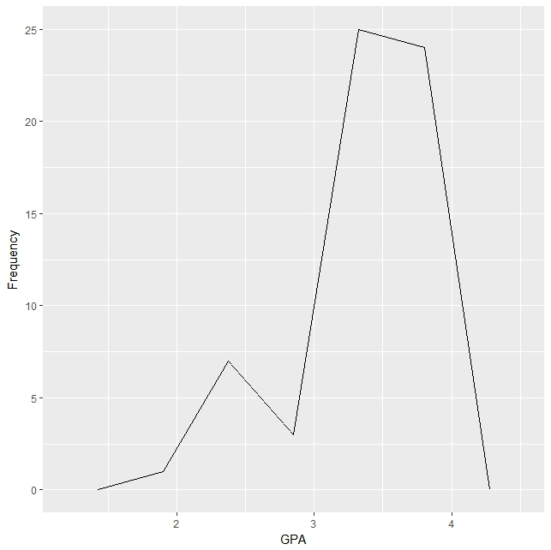

**Coding:**

**For Polygon**

install.packages(“ggplot2”)

library(ggplot2)

binsize <- diff(range(data))/4

ggplot(data.frame(data), aes(x=data)) +

# add a sensity line

geom_freqpoly(binwidth=binsize) +

# zoom out the plot a little bit

expand_limits(y=0) +

xlab( "GPA") +

ylab( "Frequency")

**6.3** Ogives (total data)

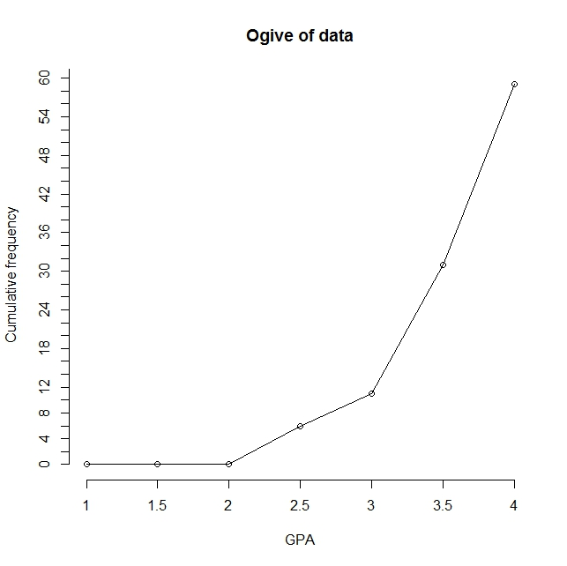

**Coding:**

**For Ogives**

breaks <- seq(1.0, 4.0, by = 0.5)

interval.cut <- cut(data, breaks, right=FALSE, dig.lab = 4)

temp.freq <- table(interval.cut)

cumfreq <- c(0, cumsum(temp.freq))

plot(breaks, cumfreq, main="Ogive of data",

xlab="GPA", ylab="Cumulative frequency", axes =

F) # y-axis label

lines(breaks, cumfreq) # join the points

axis(side=1, at =seq(1.0,4.0, 0.5), labels=seq(1.0,4.0, 0.5))

axis(side=2, at =seq(0, 62, 2), labels=seq(0, 62, 2))

**7. Method – Full Scale Analysis**

After conducting preliminary analysis, certain data relationships have come to our attention. The relationship between number of hours in part time job and CGPA has come to our attention.

We made use of measurement of central tendencies such as variance, standard deviation, etc. We also used the histograms to check for the skewness and Chebyshev’s Theorem to check how many standard deviation falls from the mean.

(Referring to Analysis on Category: Who works less than an hour). In a full-scale analysis, it is quite clear that majority of the students (11 students) who works less than one hour, obtains a 3.6 – 4.0 CGPA. The next majority of students (7 students) scores more than 3.1 – 3.5 CGPA. Interestingly, a few of the students 0(3 students) scored 2.1 – 2.5 CGPA and about 1 student scored 2.6 – 3.0 CGPA. The mean of our data in this category was found to be 3.39.

(Referring to Analysis on Category: Who works between 1 to 4 hours). In this histogram, we noticed that not one student scored less than 2.6 CGPA, and only 2 students scored between 2.6 – 3.0 CGPA. The clear majority of the students (13 students) scored between 3.1 – 3.5 CGPA and the remaining 11 students scored between 3.6 – 4.0 CGPA. The mean of our data is 3.47.

(Referring to Analysis on Category: Who works more than 4 hours). Finally, in our last histogram, we noticed that the students are spread out in all sectors of the CGPA. However, there were not many students who played more than 4 hours. We find that 3 students scored in the range of 2.1 – 2.5 CGPA while only 2 students scored in the 2.6 – 3.0 CGPA range. However, the majority of the students (5 students) scored in the 3.0 – 3.5 CGPA. And only 2 students who played more than 4 hours have more than a 3.6 CGPA. We find the mean of our data to be 3.05.

According to these data, we would like to assume our initial hypothesis was correct as the correlation between the students’ CGPA and the hours they work as part time job has some relationship. Our data concluded, that though playing around 1 – 4 hours (Figure 5), students have managed to maintain almost same results as working less than 1 hour (Figure 4), but if they play more than 4 hours than their results fall quite a bit. Therefore, we must conclude that our initial hypothesis, **students** **with higher hours in part time job have lower CGPA**, is correct and must not be rejected.

**8. General Discussion**

The research is meant to provide proof that the hours of work in part time job has a significant effect on students CGPA. The result we have obtained showed that the students who acquired better CGPA likely to spend less times in part time job. This piece of information allows us to agree to the previous study made that claimed students who spend less hours in work tend to achieve higher CGPA .

Contrary to what we have predicted, there does not appear to be any huge significant difference between the first group who work less than one hour and the second group who work between 1 and 4 hours. This leads us to speculate that all the participants were almost like one another in terms of CGPA. Although the results can be statistically significant, the study has several limitations that may affect the validity and reliability of the findings.

The first limitation is the sample. The sample size we all have decided to agree seems to be a little too small. Another limitation is we have surveyed through online forum. So, all the participants may not be true giving information.

The above limitations have paved the way to future research. One avenue for future research could be by extending the sample to population. We are also interested to discover whether other universities to obtain the similar results if they would make a survey of the same discussion topic. We believe that when we replicate this research again at a later time we could give more accurate results than now.

**9. Conclusion and Recommendation**

Our initial hypothesis states that students that have a higher number of working hours in part time job will get a lower CGPA. In terms of distraction from studying, the logical reasoning would be that the more time the student spends on working, the lesser time the students have for completing and focusing their studies. And vice versa, the lesser time the students spend on working , the more time they must focus on their studies and achieve better results.

However, we have come to find that spending less time in part time job does mean the students are going to achieve higher results. Our study focuses on the relationship between the students’ results and the number of hours they spend on a activity, which in this case is work period in part time job. Students were given options on the hours time spent (less than 1, 1 – 4, and more than 4). However, the hours vary on which day it is. Each day is not the same, the student might spend 1 hour today but play 4 hour tomorrow.

Therefore, to conclude, the relationship that we focused on is correct. We would further like to recommend a future study that would conclude with a stronger hypothesis that is not influenced by any other factors. The students’ results are mostly dependent to the hours of time spent in part time job, even though other factors might also play some role. However, based on previous studies, it is suggested to minimize the number of hours in part time job.

**10. References & Appendix**

1.https://www.researchgate.net/publication/276224110_Does_Part-Time_Job_Affect_College_Students%27_Satisfaction_and_Academic_Performance_GPA_The_Case_of_a_Mid-Sized_Public_University

2.https://www.google.com/search?client=firefox-b-ab&q=do+part+time+jobs+affect+students+grades&sa=X&ved=0ahUKEwiVwsrvhPnaAhXCPY8KHYK7CmkQ1QIIsAEoAg&biw=1536&bih=702

3.http://education.seattlepi.com/afterschool-work-affect-school-performance-1747.html

4. https://prezi.com/6yb5trsq8kev/does-a-job-affect-the-students-grades/

5.https://www.timeshighereducation.com/news/part-time-working-can-harm-studies/105562.article

Thank You